**CHAPTER 1**

**INTRODUCTION**

* 1. **Motivation**

Safety is a necessary part of human’s life. Due to accidents cases reported daily on the major roads in all parts of the developed and developing countries, more attention in needed. As the rate of the accidents are increasing day by day, speed of the vehicles should be controlled as much as possible. Most of the accidents in India occurs due to lack of speed of control and violating the road rules. So, to avoid accidents we came up with this idea of “AUTOMATIC SPEED CONTROL SYSTEM IN DIFFERENT LANES”.

In this system the speed of the vehicle is detected depending on the speed limit set the message is sent to driver and control room. These will reduce the number of accidents happening due to exceeding the speed limit set by government. These is lifesaving project.

* 1. **Scope**

Scope of the project is future every vehicle will have such type of the system that will reduce number of fatal accidents. This project is a simple project using simple Arduino board and GPS module to reduce the speed of the vehicle according the limits set there. By this project the accidents due to the over speeding.

* 1. **Objectives**

The project is about the speed limiting in vehicles. In this project we show how to control the speed of vehicles on highway, near a school, on country road…etc. Most of the fatal or serious accidents are associated with over speed and rash driving. So, to avoid such accidents we are implementing this project. These systems offer excellent opportunities to control vehicle speeds and movements in order to avoid accidents but they rely, of course, on sophisticated features built into the roadway and vehicle.

But various types of accident are occurred on express highway road, highway road, off road just because of small uncertain activities. Rash driving, system failure, collision due to obstacles, exiting speed control limit etc. are just some causes of accidents. Speed control at particular type of road is also necessary to avoid accidents. For this, there is no any system to control the speed of vehicle. That’s why, there is need to invent such system which control the speed of vehicle automatically at given limit at particular limiting distance. Now it is possible to control or set the speed of vehicle at a given limit on the roads like highways.

* 1. **Need for Product Realization**

The need for the project in the society Is very high. We are designing the product for the future development there can be a lot of research work done on this project to improve the accuracy to get better results. Our project AUTOMATIC SPEED CONTROLLING SYSTEM is very useful in reducing the accidents caused by the over speeding of the vehicles. In this project we specify the zones through the GPS and the vehicle speed is limited to the certain speed up to the zone. We are designing a basic model for demonstrating the topic and further we can do a lot of research and develop the project further based on the requirements.

**Product Realization Process**

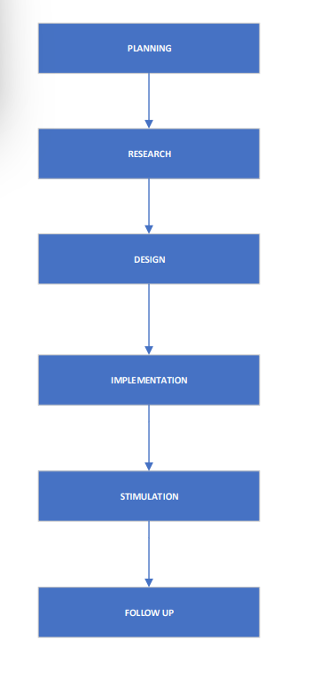

**Fig 1: Project realization process**

**CHAPTER 2**

**PRODUCT REALIZATION PLANNING**

**2.1 Flow Chart**

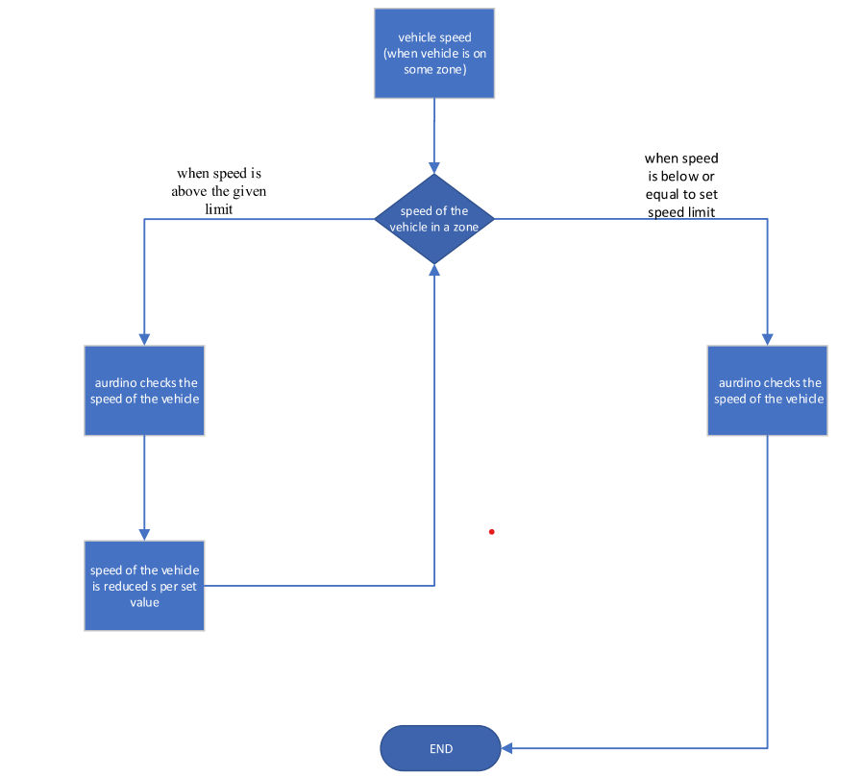

**Fig 2: flow chart for working of automated speed limiting system**

**2.2 Steps involved for Product Realization**

**Step 1: [Planning]**

After the deciding of the topic, we headed for the planning process of the project in the planning we discussed what are the requirements for the prototype and the steps that we need to do to complete the prototype successfully.

**Step 2: [Research process]**

After the completion of the planning, we headed for the research process for the gathering of the required information of the prototype.

**Step 3: [Design]**

After the completion of the research work, we headed for the designing of the prototype in this stage we brought the components required for the prototype and we are connecting the components based on the circuit.

**Step 4: [Implementation]**

After the completion of the design work, we headed for the implementation of the prototype. We are checking if all the parameters for the prototype are checked and verified.

**Step 5: [Simulation]**

After the implementation we gave the prototype to the people for the testing and checking he simulation of the prototype.

**Step 6: [Follow up]**

After all the steps we are taking the suggestions from the people and noting down their comments for the future development of the prototype and we are trying to solve any errors in the prototype there itself**.**

**2.3 Gantt Chart**

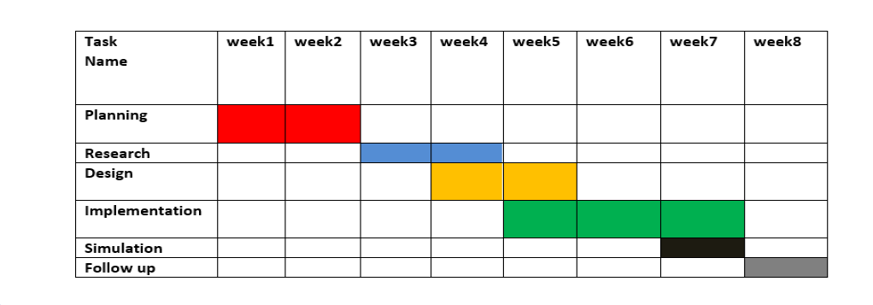

**Fig 3: Gantt chart of the project**

**CHAPTER 3**

**Community partner-Related Processes**

**3.1 Details of Community partner:**

Name: G. Kishore

Designation: Automobile Engineer

Address: Shivpuri colony, Manikonda

Phone Number:8897212370

**3.2 A field survey form**

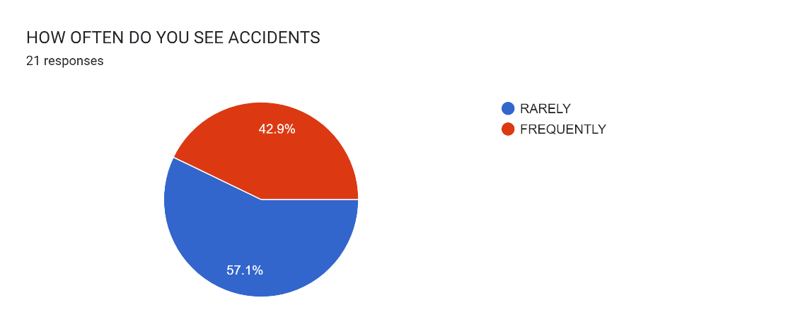

**Fig 4: Responses on review (question 1)**

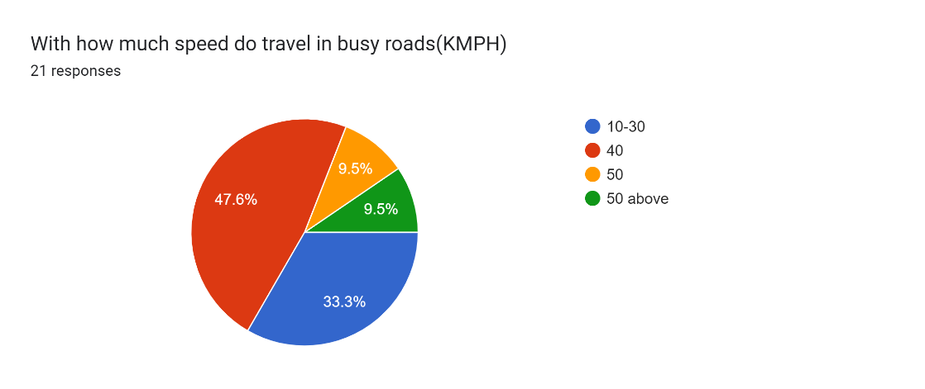

**Fig 5: Responses on review (question 2)**

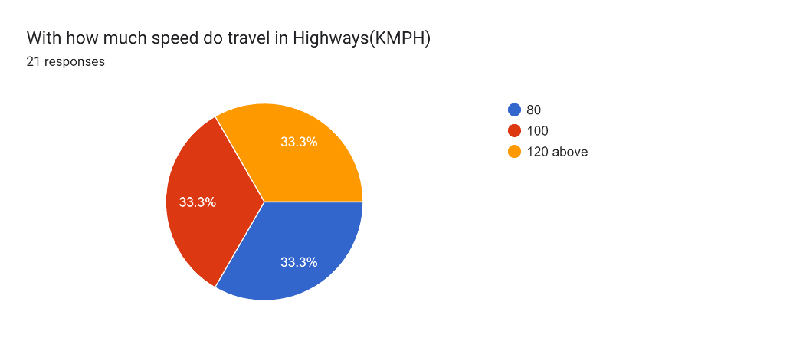

**Fig 6: Responses on review (question 3)**

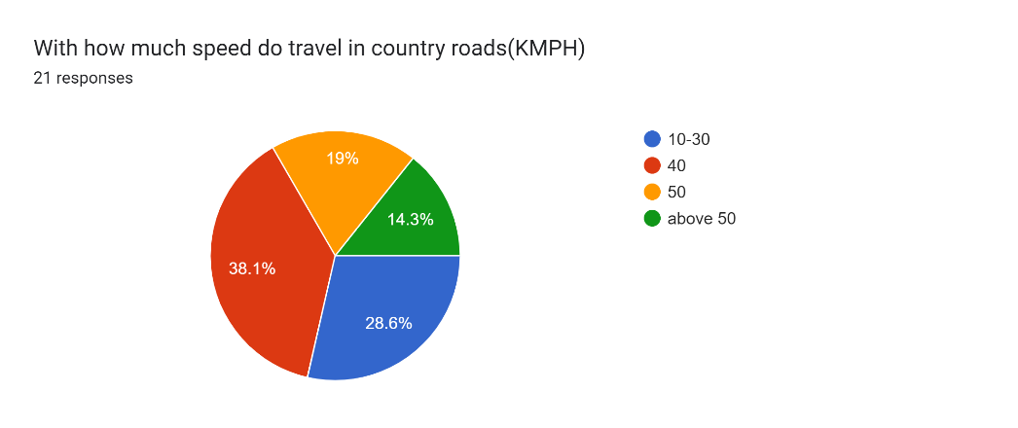

**Fig 7: Responses on review (question 4)**

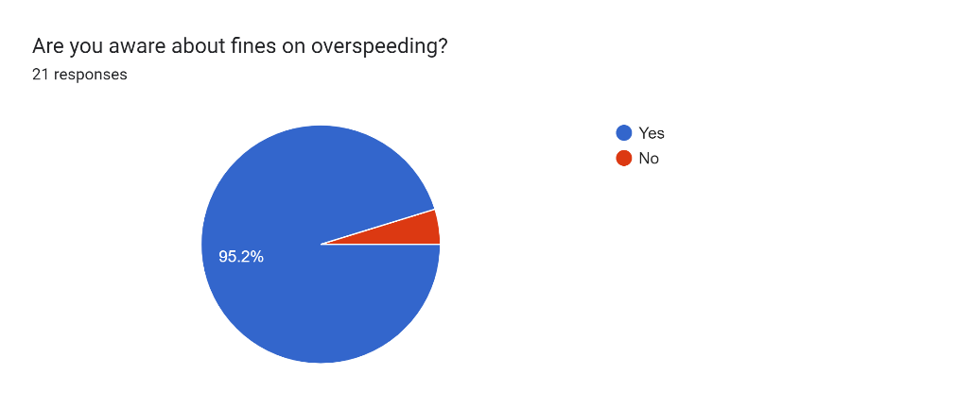

**Fig 8: Responses on review (question 5)**

**3.3 Questioner with Community Partners responses**

**[1]** *How did you get the idea of the project?*

**Ans:** From reading the newspapers daily I got through the news of accidents happening in certain areas due to the over speeding of vehicles like in the school areas and accident-prone areas. After that our group took an initiative to solve or reduce the accidents by reducing the speed of the vehicles then we came up with the idea of automatic speed reduction system.

**[2]** *What are the various zones that are there in your project?*

**Ans:** School zone

Highway

Country

Accident prone area

**[3]** *What are the speed limits in the specified different zones?*

**Ans:** Speeds for the zones are mentioned in KMPH (kilometers per hour)

* School zone (10-25).
* Highway (80-100).
* Country (60-80).
* Accidents-prone area (20-40).

**[4]** *What are the differences between the current available products and our product?*

**Ans:** The currently available products in the markets does not reduce the speed of the vehicle based on the GPS location in our project the speed of the project is reduced through the location which is not available in the market. Our prototype is way more accurate and cost efficient compared to the other products available.

**3.4 List the Community Partner Specifications**

The community partner after the interaction gave us sone suggestions. Some of them are:

He suggested to increase the zones Ans the speed limits. He suggested to increase the speed limit a little bit because he/she may have any emergencies. He suggested to send an SMS to the registered mobile number for over speeding. He suggested to reduce the cost and make it affordable for all the people.

**CHAPTER 4**

**Design and Development of Product**

**4.1 Design of Product:**

Here we are using Arduino UNO, at first to vary the speed of the DC Motor we will connect the dc motor to the Arduino and L 293D.At first, we connect pins 2 and 3 of IC to the motor. Then IN1 of the IC to the pin 8 of Arduino. Connect IN2 of the IC to pin 9 of Arduino. Connect EN1 of IC to pin 2 of Arduino. Connect SENS A pin of IC to the ground. So that we can maintain different speeds of dc motor by connecting 5V battery to it. Then we connected the GPS module to the Arduino. Connect 5V from the Arduino to Vin on the GPS Breakout. Connect GND to GND. Connect the Rx Pin from the GPS Module to Digital Pin 2 on the Arduino. Connect the Tx Pin from the GPS Module to Digital Pin 3 on the Arduino. By connecting and the above connections to the Arduino UNO, connect Arduino to the PC or laptop and the motor to the 5V battery (as power supply to the battery) and run the code where the speeds of the different zones are set in Arduino IDE.

**4.2 Purchasing information**

| **COMPONENT** | **QUANTITY** | **Amount in Rs** |
| --- | --- | --- |
| Arduino UNO | 1 | 450 |
| GPS module | 1 | 1000 |
| Jumper wires | 4 | 100 |
| DC motor | 1 | 30 |
| Battery | 3 | 75 |
| L293D | 1 | 30 |
| Bread board | 1 | 50 |
| Arduino cable | 1 | 100 |
| TOTAL |  | 1770 |

**4.3 Development Process**

At first, we sketched the basic circuit diagram to connect the components then we connected the components based on the circuit then we modified the circuit according to the specifications given by the community partner. Then we wrote the Arduino code and transferred it into the Arduino. Then we tested the prototype and send it to the community partner and they checked and gave us suggestions and feedback for the future development.

**4.4 Final Product**

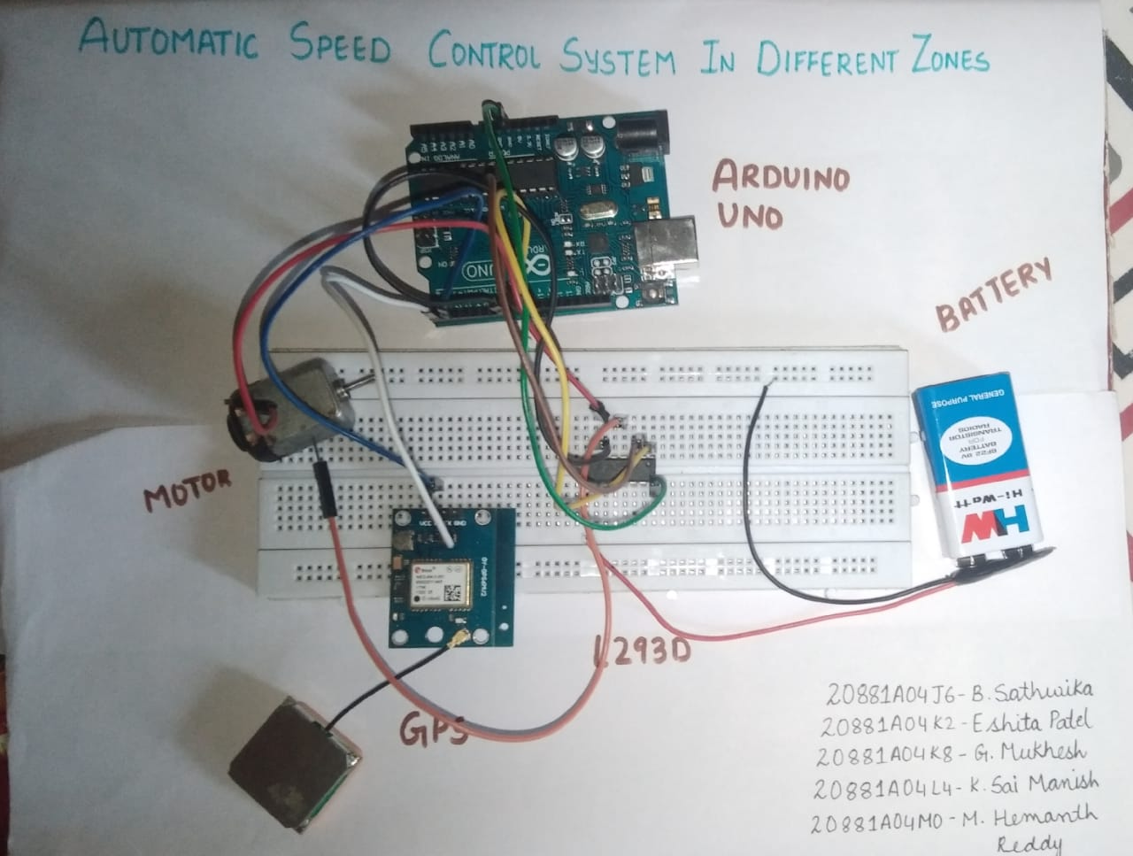

**Fig 9: Automated speed control system**

**CHAPTER 5**

**Post Product Realization Activities**

**5.1 Delivery details (Date, Place, means etc.,)**

We delivered the prototype on august-1 2022 to our partner G.Kishore who is located at Hyderabad .we took the prototype ourself and fixed the components to the vehicle and the testing was done.

**5.2 Feedback on delivered product**

The community partner is satisfied with the prototype. The community partner checked the prototype in different conditions and the prototype is successfully working in most of the conditions. The partner suggested us to increase the accuracy of the prototype and to produce in a big scale for the supplying a wider community. Most of the people are satisfied with the prototype supplied.

**CHAPTER 6**

**Business Model/Paper/Patent information**

The project “AUTOMATED SPEED LIMIT DEVICE IN DIFFERENT ZONES” is for the safety of the people on the roads and the people in the vehicle to reduce accidents caused by over speeding. This project can be applied to the patent rights. The product is developed and it is launched for the people and safety of the people. If patent right is provided then this product can be accepted worldwide. Adding some new features into it, this application can be developed further more.

**CHAPTER 7**

**CONCLUSION**

The execution of the prototype is done successfully and all the requirements’ parameters for the prototype are achieved successfully. All the required feedbacks and suggestions addressed by the customers are noted down and will be solved in the future development of the project.

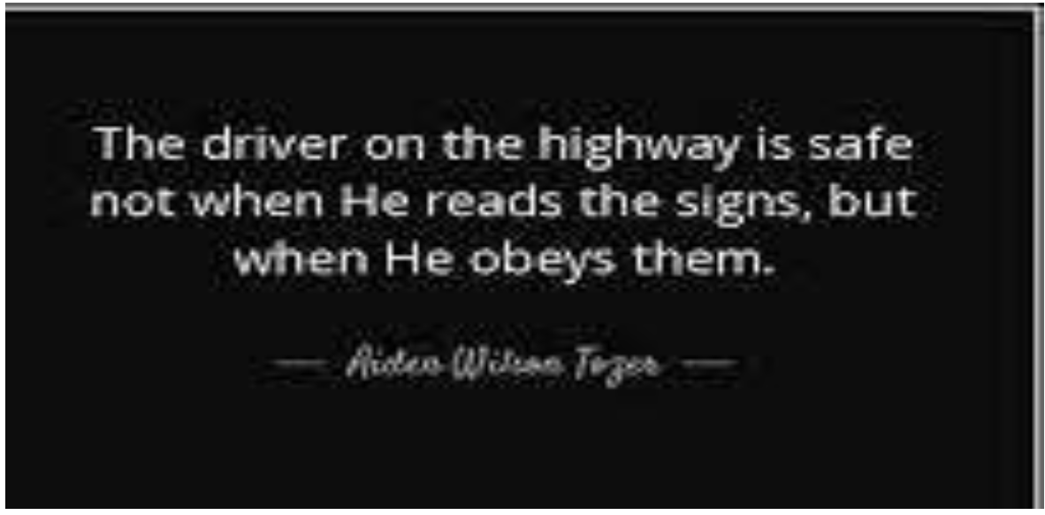

**Fig 10: Motivation**

**REFERENCES**

[1] Amulya A M, et.al., Intelligent speed control system, Volume 5, Issue 4, April 2018, pp.2537-2540.

[2] Vaishal B. Niranjane, et.al., Automatic Vehicle Speed Control System Using Zigbee Technology, IJEECS ISSN 2348-117X Volume 6, Issue 3, March 2017.

[3] Amarnarayan, et.al., Automatic Over speed Controlling of Vehicle, eISSN:2321-225X, pISSN:2321-224.

[4] Vehicle speed controlling system using embedded and wireless systems, S.Ahalya , Umapathy.